Ceylonese Woman
Julia Margaret Cameron | ca. 1875–79 | Record IMG-SA0005

1. Original Image
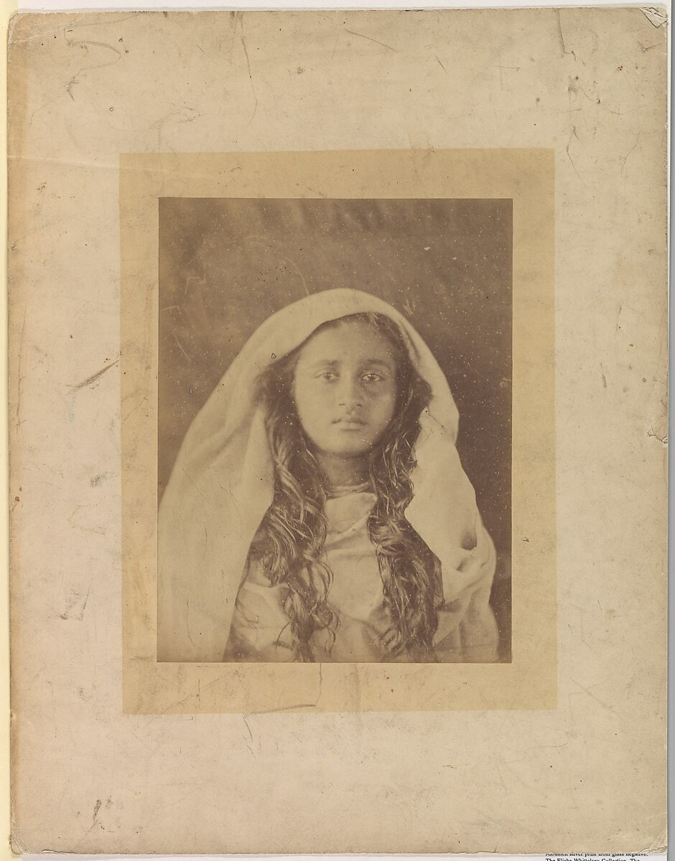
IMG-SA0005. Ceylonese Woman, Julia Margaret Cameron (British (born India), Calcutta 1815–1879 Kalutara, Ceylon), 1875–79, Albumen silver print from glass negative. The Metropolitan Museum of Art.

2. Record Summary
Record ID | IMG-SA0005
Original title | Ceylonese Woman
English title | Woman from Ceylon; historical institutional title retained separately
Alternative title | “Ceylonese” uses the historical colonial name Ceylon; the country is now Sri Lanka
Creator | Julia Margaret Cameron
Creation date | 1875–79
Country | Sri Lanka
Cultural region | South Asia; historical Ceylon
Historical period | Late nineteenth-century British colonial Ceylon
Image type | Photography
Medium | Albumen silver print from glass negative
Dimensions | Not verified
Primary subject | Head-and-shoulders portrait of a woman
Secondary subjects | Head covering, long hair and deteriorated mount
Source institution | The Metropolitan Museum of Art
Collection or object number (optional) | 69.607.3

3. Image Description

3.1 Short Description
A mounted head-and-shoulders portrait shows one young woman facing forward. A light cloth covers the top and sides of her head, while long wavy hair falls over both shoulders. The pale print is surrounded by a mount marked with stains, scratches and uneven discolouration.

3.2 Detailed Visual Description
The woman faces the camera with her head upright and gaze directed forward or slightly upward. A translucent cloth drapes over the crown and descends beside the face. Long dark hair falls across both shoulders. The facial details are softly rendered, particularly around the eyes and mouth.
The print is centred on a larger cream mount. Scratches, stains, abrasions and fading are visible across the mount and near the photograph. The background is plain and light, merging with the head covering. No additional people, architecture, objects or text are visible.

4. Formal Features
Field | Analysis
Composition | Centred frontal face with symmetrical hair.
Viewpoint or camera angle | Face level..
Shot scale | Head-and-shoulders portrait.
Spatial depth | Very shallow.
Lighting | Soft frontal illumination.
Colour palette | Pale cream, beige and brown.
Contrast | Low to moderate.
Visual focus | Eyes and facial oval.
Texture | Hair and cloth contrast with the damaged mount.
Movement or stillness | Completely still.
Medium-specific features | Soft focus, albumen tonality and mount deterioration.

5. Historical Context and Purpose

5.1 Historical Context
Cameron continued making photographs after moving to Ceylon during the 1870s. The Met dates this portrait to 1875–79 and retains the historical title Ceylonese Woman. That title provides a broad geographic label but does not identify the sitter by name, community or circumstances. The portrait was produced within a colonial context, making its classification and circulation ethically significant. [IMG-SA0005-S01] Image Purpose and Circulation

5.2 Image Purpose and Circulation
Original purpose: Not verified.
Probable purpose: Portrait study within Cameron’s photographic practice in Ceylon.
Current institutional use: Historical portrait photography.

